Practical no. 24
Name :- Danish Altaf Solkar Enrolment no. :-24111590805
Class :- CO3K – B Subject :- OOP
Aim :- Write a program to copy the contents of one file into another file.
Program :-
#include <iostream.h>
#include <conio.h>
#include <fstream.h>
void main()
{
clrscr();
ifstream fin("source.txt", ios::in); // file to read from
ofstream fout("destination.txt", ios::out); // file to write into
char ch;
if (!fin)
{
cout << "Source file could not be opened!";
getch();
return;
}
cout << "Copying content...\n";
while (fin.get(ch))
fout.put(ch);
fin.close();
fout.close();
cout << "Content copied successfully!\n";
ifstream fin2("destination.txt", ios::in);
cout << "\nContent of destination file:\n";
while (fin2.get(ch))
cout << ch;
fin2.close();
getch();
}
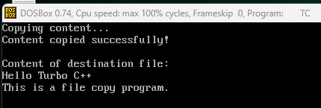
Output :-

